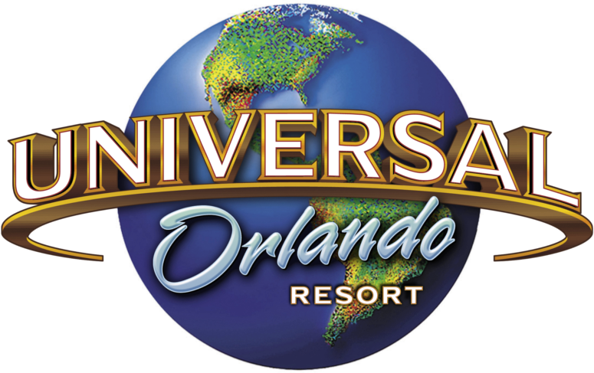
Today our trip takes us to Universal Studios in Orlando Florida. Here is a list of some rides and shows for us to experience. Go to www.youtube.com and search for each of these rides/shows under Universal Studios and the ride’s name. Example: Universal Studios Shrek4D. When you are finished watching, write down which ride you like the best and why.
- Shrek 4D 6. Woody Woodpecker’s Nuthouse Coaster
- Hogwarts Express 7. E.T. Adventure
- TRANSFORMERS The Ride 3D 8. Men in Black Alien Attack
- The Simpson Ride 9. Animal Actors on Location (show)
- Harry Potter and the Escape from 10. Despicable Me Minion Mayhem
Gringotts

Some flash back rides to check out:
Jaws Twister Kongfrontation
Earthquake Ride Back to the Future Ride

